**EXPERIMENT 4**

Create a combination lock that interrupts a running motor

*Description:* A password is defined in the code that defines the password for the combination lock that will stop a running motor. Essentially, portions of the motor is initiated to either run it or stop it. Initially, the motor is running, if a user enters the correct password, the motor is stopped.

**Main code:**

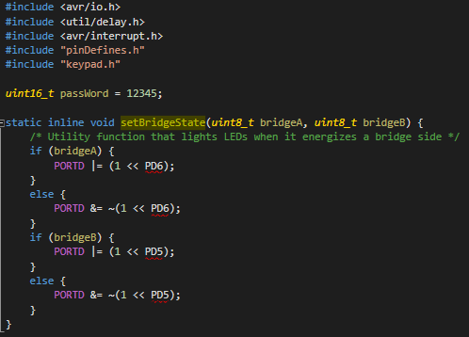

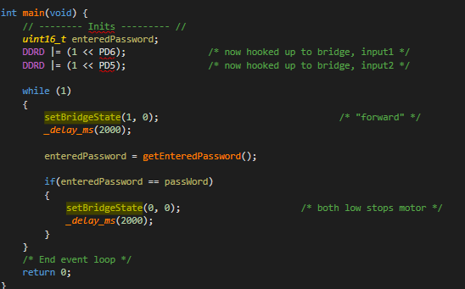

**Keypad for combination Code:**

*keypad.h*

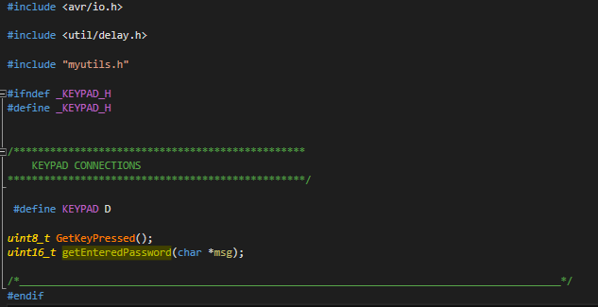

*keypad.c*

